Galatians 6:9; Romans 6:6-7
Successful people do Consistently what other people do Occasionally
We connect our Failure to our Identity; Romans 7:24
1. We focus on the What but we do not understand the How
- We focus on the Action we want to Perform but we don’t understand How to get there
- You will not rise to the level of your Goals; you will fall to the level of your Systems
- Daniel Pre-decided 3x a day, Every day, he would Stop to spend time with God
- We need to change the Systems that create unwanted Results
- If we change what we Do, the Outcomes will fix themselves
2. We do not see Progress fast enough
- We do not see much of a Difference and wrongly conclude that Small good decisions don’t Matter that much
- Your life is the Sum Total of all the Decisions you have made
- Who you are Today is the result of every single Small decision you have made along the Way
- One small, Faithful decision after Another will lead you to the place where everyone else wants to Be
- The things No One sees are what bring Results everyone wants
3. Our distorted Identity sabotages our Success
- An unhealthy Identity creates unwise Habits
- Then the unwise Habits reinforce the unhealthy Identity
- Challenge: Start with Who goals instead of What goals
- When you know Who you are, you know What to do
- The Do overflows out of the Who
- Positive Habits reinforce a healthy Identity
- When you know who you Are, you will know what to Do
Honolulu Assembly of God Habits January 9, 2022
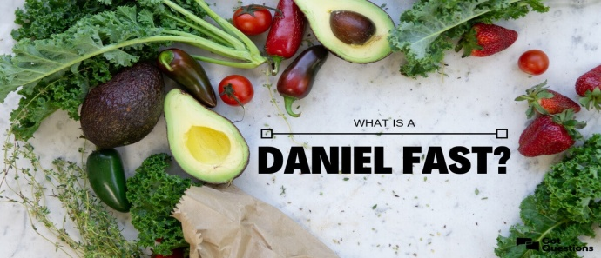
Foods to Eat on the Daniel Fast
- All fruit – fresh, frozen, dried, juiced, or canned.
- All vegetables – fresh, frozen, dried, juiced, or canned.
- All whole grains – whole wheat, brown rice, millet, quinoa, oats, barley, grits, whole wheat pasta, whole wheat tortillas, rice cakes and popcorn.
- All nuts & seeds – almonds, cashews, macadamia nuts, peanuts, pecans, pine nuts, walnuts, pumpkin seeds, sesame seeds, and sunflower seeds; unsweetened almond milk. Nut butters are also included.
- All legumes - canned or dried; black beans, black eyed peas, cannellini beans, garbanzo beans (chickpeas), great northern beans, kidney beans, lentils, pinto beans, and split peas.
- All quality oils – canola, coconut, grape seed, olive, peanut, and sesame.
- Beverages – distilled water, filtered water, and spring water.
- Other – unsweetened almond milk, rice milk, or soy milk; herbs, spices, salt, pepper, seasonings, soy products, and tofu.
Foods to Avoid on the Daniel Fast
- All meat & animal products – beef, fish, lamb, poultry, and pork.
- All dairy products – butter, cheese, cream, eggs, and milk.
- All sweeteners – agave nectar, artificial sweeteners, cane juice, honey, molasses, raw sugar, syrups, stevia, and sugar.
- All leavened bread & yeast – baked goods and Ezekiel bread
(if it contains yeast and honey).
- All refined & processed food products – artificial flavorings, chemicals, food additives, preservatives, white flour, white rice.
- All deep-fried foods – corn chips, French fries, potato chips.
- All solid fats – lard, margarine, shortening and foods high in fat.
- Beverages –carbonated drinks, coffee, energy drinks, herbal tea, and tea.
Special Note: If you have health issues, please be sure to contact your health professional for advice before committing to any fast including the Daniel Fast.
Source: https://danielfast.wordpress.com/daniel-fast-food-list/

