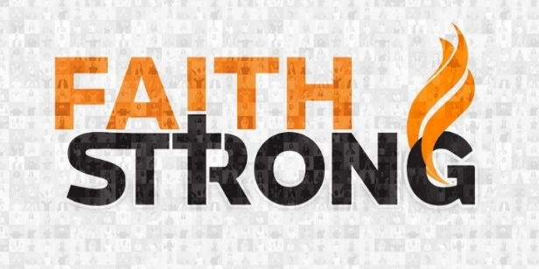
Be Strong and Courageous! Joshua 1:6-9
A. Be Strong and Courageous v6-7a
- There are Battles to fight
- There are Giants to conquer
- God has called you to Go Forth in Victory
- You cannot walk in Fear and Discouragement
- Jesus Christ has Already won the Victory
- Great Courage comes from great Faith
- Nothing will happen to you that is too Big for God
- We serve an Awesome God
- There is Nothing too Hard for Him
B. Live God’s Word v7b-8
- Keep it Central in your life, like fuel or food
- Why? The Word builds Faith in your heart
- If you are not Living in the Word, you will Wither and Die, like a tree with little or no Root system
- You can’t just Survive; you must be an Overcomer
- Don’t live Beneath your birthright! Live the Word
C. God is With you Wherever you go v9
- Joshua was given Assurance (v5): “As I was with Moses, so I will be with You”
- Success come from God’s Presence
- Everywhere you go, Jesus Christ is With you
This Week: Don’t let Faith-killers rob you of the victory. The enemy will do its best to Defeat you but have Faith in God. Be Strong and Courageous!
Honolulu Assembly of God Faith Strong! November 5, 2023

