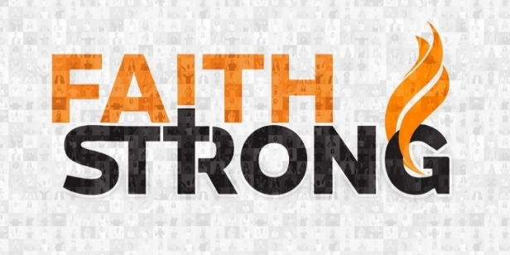
Unleash your Faith! Mark 9:21-24

A. Jesus’ Teaching on Faith
- Background: Jesus’ Miraculous Transfiguration; Matthew 17:1-8
He came in Humility; now He is revealing His Majesty
- The Scene below the Mountain
A Desperate father and a Hurting son; Mark 9:21-24
- Jesus emphasizes the Necessity of Faith
If have faith like a grain of Mustard Seed, cast mountain into the Sea
“Nothing will be impossible for you.” Matthew 17:19-20

B. Definition: What is Faith?
- What Faith is Not
- Not about Emotions or Feelings
- Not about Mind over Matter
- It’s not seeing what is not There but what is not Seen
- Not even the difference between a Christian and non-Christian
- Everyone has some kind of faith
- The difference is the Object of your faith
- Faith is only as Effective as what you have faith In
- What Faith Is
- Living in a Miracle on the edge of a Disaster
- Believing in Advance in something that will only make sense when seen in Reverse
- Faith is Obeying God
- In spite of Feelings
- In spite of Circumstances
- In spite of Consequences
This Week: Let go and let God have control.
Step out in Faith and trust Jesus for a Miracle!
Honolulu Assembly of God Faith Strong! October 22, 2023

