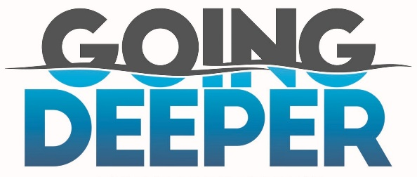
Nothing but Jesus! 1 Corinthians 2:1-2
A. God is our Refuge and Strength; Psalm 46:1-3
- Therefore, I will not Fear
- Even in the midst of Disaster and Tragedy
- The Lord is my Rock; Psalm 18:1-3
• When everything I am holding on to Crumbles, He is my Sure Foundation
• Though the Earth may Fail, He will not fail
B. There is Nothing and No One Else but Jesus
- Shaking and Quaking remind us that Nothing and No one else will Last
- God uses Trouble to display His Strength
- He uses Pressure in our lives to show us what we are Depending on
- When you have nothing Left but Jesus, you realize you don’t Need anything else but Jesus
- When you are mourning what you have Lost, you are also realizing what you have put your Confidence in
- When Everything falls apart, you realize you have Nothing left but Jesus
C. Jesus is All you Need
- We cannot Trust in the Emblems of Power; Psalm 20:7-8
- Put your Trust and Confidence in Jesus, the Essence of Power
- Surrender Everything to Him
D. What is the Solution?
- I will Call upon the Lord; Psalm 18:3
- Prayer: Banish Worry and let the Peace of God rule in your heart; Philippians 4:6-7
- Praise: As you begin to Praise the Lord, you begin to get a Bigger Picture of Who He is
- Before all you could see was the Problem; Soon, you know that Jesus is Bigger than the mountain
- You realize that Jesus has been Bigger than the Mountain All the Time
Honolulu Assembly of God Going Deeper! February 11, 2024

