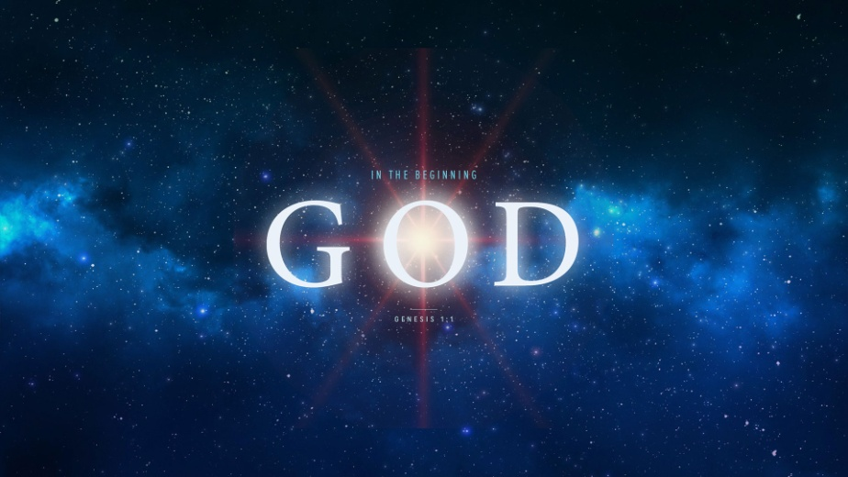
Are you Ready for Eternity?
Genesis 5:1-20
1. Death
- Death is Inevitable and Inescapable
- We try hard to Escape death but we Cannot
- We must be Ready for Death
- First comes Death, then comes Judgment
- Death is merely a Transition; not a Destination but a Doorway
- If Death is a Doorway, what is on the Other Side of the door?
2. Eternity
- Eternity without Christ is Hell
- The greatest Agony will be Eternal Separation from Christ
- Eternity with Christ is Heaven
- The greatest Joy will be Eternal Union with Christ
- Because of Jesus Christ we can face Eternity with Confidence
- He has won the Victory and Triumphed over death
Honolulu Assembly of God In the Beginning God! September 2, 2020

