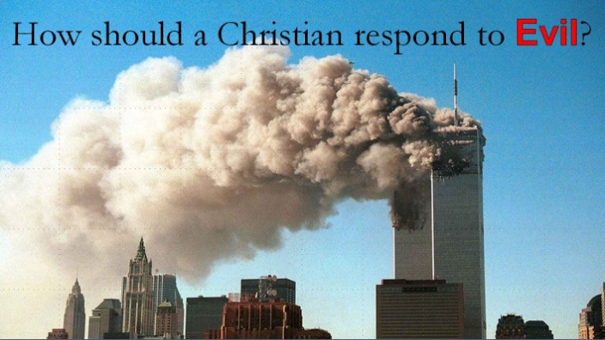
Habakkuk 1:1-4
A. We live in a Sinful and Broken world
- All have Sinned and fall Short of the glory of God; Romans 3:23
- Sinful Man does sinful Things
- The world is Infected by sin; it is groaning for Redemption
B. God is in Control!
- Nothing man can do will threaten God’s Plan or Purpose
- It might be a Shock to us but not to God
- God is on the Throne and Reigns forevermore
C. God is Good All the time!
- We must believe God not only has all Authority but is all Good
- His love and mercy are our rock solid Foundation
D. We are involved in a Spiritual Battle
- Our struggle is not against People but against spiritual Enemies
- The battle might be Fierce, even devastating at times, but the Outcome is never in doubt
- Jesus Christ will have the Victory!
E. Prayer makes the Difference
- Since it is a spiritual Battle, we must use spiritual Weapons
- Prayer is not overcoming God’s Reluctance; it is taking hold of His Willingness
- God is more willing to Intervene than we are to Intercede
F. We must be willing to Stand in the Gap
- God is looking for Men and Women who will rise up and make a Difference
- The Church is called to be Salt and Light
Honolulu Assembly of God September 12, 2021

