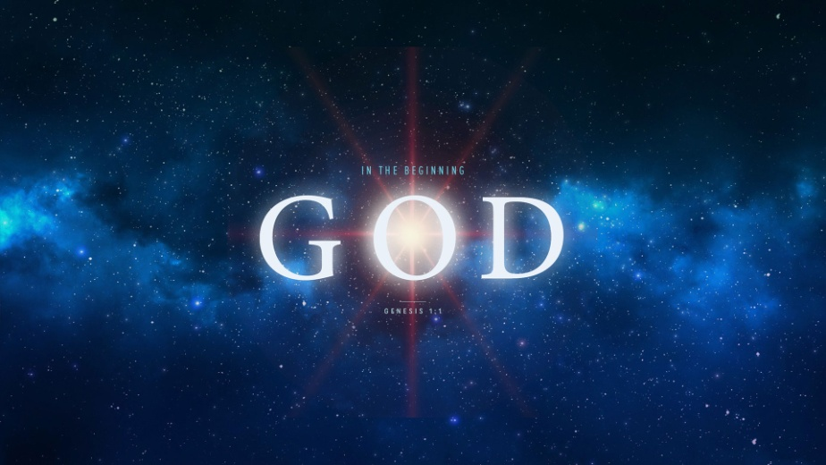
In the Beginning God Created
Genesis 1:1-26
1. The Beauty of Creation
- The Intricate and Complex Design of Creation implies the Wonder of the Creator
- There is a Beautiful sense of Balance in Genesis 1
- Days of Forming; v3, 7, 9, 11
- Days of Filling; v14, 21, 24-26
- Imagine being a Spectator on the days of Creation
2. The Power of Creation
- The Complexity of the Universe
- Genesis 1: God Spoke the Word and it was so
- He created the world out of Nothing
- Key: Science and the Bible are not Incompatible
- Major scientific discoveries were made by people who believed God created all things
- No one was there at the Beginning so Faith is required
3. The Lessons of Creation
- He is Mighty
- There is Nothing He cannot do
- He is Sovereign
- He made Everything and He has All authority
- He is in Control
- A God who can create All deserves All
Honolulu Assembly of God In the Beginning God July 19, 2018

