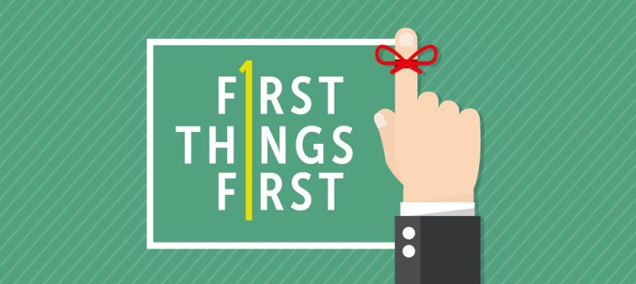
A. Make the Big Decision; Joshua 24:14-15
- Don’t put the Sand in first; put the Big Rocks in first
- Choose for yourselves this day whom you will Serve
- As for Me and my House, we will serve the Lord
- By choosing to submit your life to the Lordship of Jesus Christ, you will have answered many of the Questions of Life
- In 2024, make Jesus Christ the Lord of your life
B. Forget the Past; Philippians 3:13-14
- Get Rid of the Junk
- Don’t be Defined by your Past
- Don’t let your Yesterdays drive your Tomorrows
- Start Fresh
- God is doing a New thing; Revelation 21:5
C. Live an Uncompromised Life; Daniel 1:8
- Don’t Straddle the Fence
- Don’t try to live for Jesus and for the World
- Daily Live the Word of God
- In order to obey God’s word, we must Know God’s word
- When you learn a new truth, Apply it to your life
D. Invest yourself Completely for Jesus; Revelation 3:16
- Being a half-hearted Christian is Miserable
- Challenge: Either go All Out for Christ or Quit
- Serve Christ with Passion
- Contribute to the Kingdom of God
- What will you Do for the Lord and His church?
- Each one can do Something for the Lord
- Investing your life for Jesus will pay Eternal rewards
- When you make the right Investment, it will yield a good Return
Honolulu Assembly of God January 21, 2024

