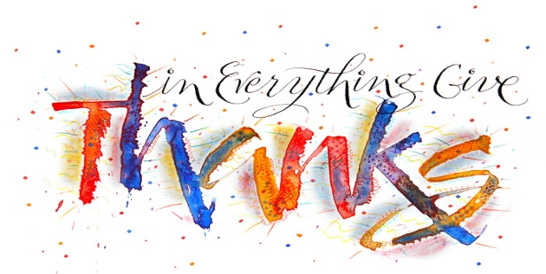
1 Thessalonians 5:18
A. Thanks-Living reminds me that I must give Account to a Higher Authority
- When you think of all the Blessings you have received, to Whom do you give thanks?
- Psalm 103:1-5; God’s Giving deserves our Thanksgiving!
B. Thanks-Living reminds me of the Power of a Right Attitude
- Trials and Tribulations come to us all
- Some people become Sour and Cranky
- Others become Sweet and Kind
- Use Trials and Tribulations as Stepping Stones to grow closer to God
- Are you an Act-or or React-or?
- If you don’t have all the things you Want, be grateful for all you don’t have that you Don’t want
- A Thankful Heart leads to a Joyful Heart
C. Thanks-Living is Key to an Overcoming Christian Life
- God is in Control and He is Good!
- Philippians 1:12-18; We do not thank God For everything but In everything
- There is a relationship between Thanksgiving and Trust
- Basis: God is Good! All the Time!
- There is a relationship between Thanksgiving and Power in prayer
- The Two-fold Power of Giving Thanks
- Giving thanks releases Faith in prayer
- Like praise, giving thanks builds Confidence in God’s desire and ability to help
- When you have confidence in God’s Ability, that He Can and Will intervene, then you can begin to Rest in Him and Thank Him for the answer; Philippians 4:4-7
Honolulu Assembly of God November 21, 2021

