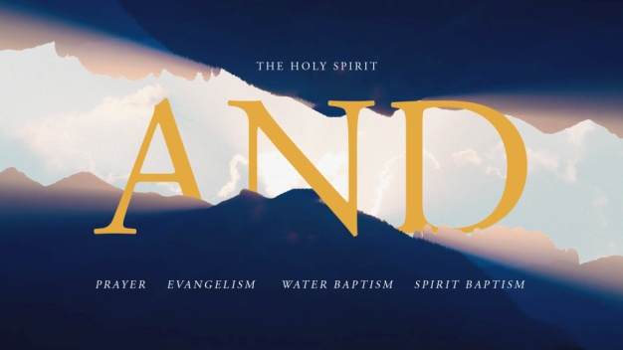
The Holy Spirit and Water Baptism
John 1:19-34; Matthew 28:18-20
A. John the Baptist’s Identity; John 1:19-28
- He was not the Messiah, nor Elijah, nor the Prophet; v21-22
- Instead, he was a Voice crying in the Wilderness; v23
B. Jesus’ Identity; John 1:29-34
- He is the Lamb of God, the ultimate Sacrifice for sin; v29
- The Holy Spirit’s Presence at Jesus’ water baptism was God’s ordained Sign that Jesus was indeed the Messiah; v32-34
C. Our Identity; Matthew 28:16-20
- This passage gives Christians many roles of identity: Authorized Ones (v19), Disciples and Disciple Makers (v19), Baptized Ones (v19), Declarers of Triune God (v19), Obeyers (v20), Never Alone Ones (v20)
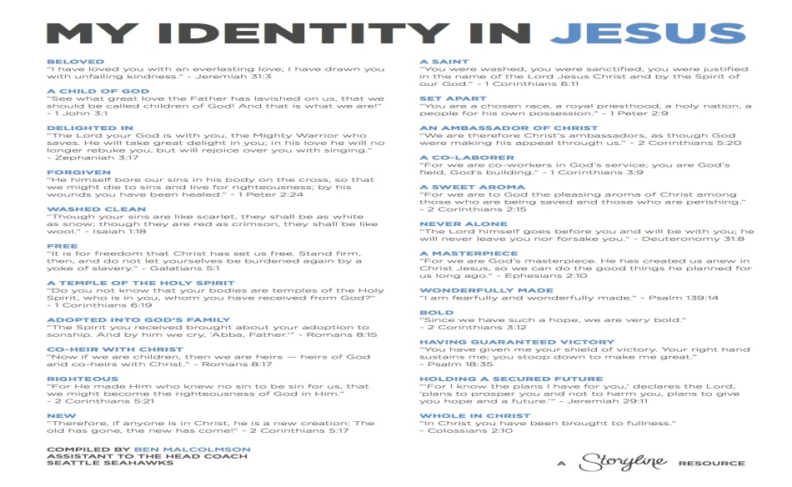
Honolulu Assembly of God AND May 29, 2022

