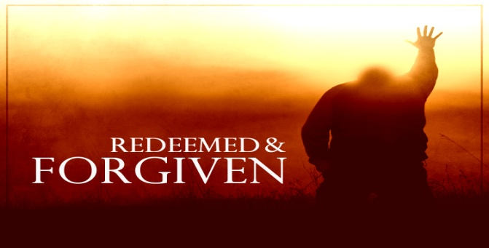
Ephesians 1:3-8; Colossians 1:13-14
A. You are Redeemed
- The Definition of Redemption
- To Gain or Regain possession of (something) in exchange for Payment
- It is the Work of the Trinity: The Father Demands and Provides, Jesus Pays and the Holy Spirit Applies
- The Basis of Redemption: The shed Blood of Jesus Christ
- Heb 9:22 “Without the shedding of blood, there is no Remission or Forgiveness of sin”
- Old Testament picture: Kinsman-Redeemer (Goel); Ruth 3-4
- He must be Willing to redeem; 2 Peter 3:9
- He must be Able to redeem; Hebrews 7:25
B You are Forgiven
- The Agony of Sin and Shame
- Satan loads a giant Weight upon your back; he ties a Noose around your neck
- Forgiveness brings you Freedom
- Jesus Christ has forgiven you of Everything; 1 John 1:9
- The Extent of Forgiveness
- There is No record of your life before you met JC
- The On-Going Process of Forgiveness
- Your Past is Gone!
- There is no more Weight of sin holding you Down
- Application: Our Forgiveness of Others (To/Through)
- Not the Forgiveness you Receive, but that which you Give
April 25, 2021 A Brand New You Honolulu Assembly of God

