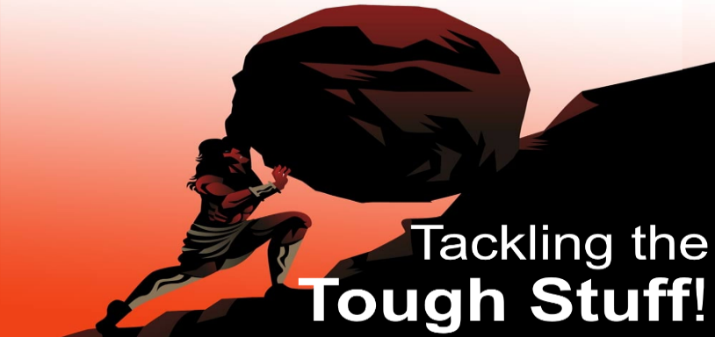
Guilt
Cancel your Guilt Trip and Live in Freedom!
Romans 8:1-2
A. What Kinds of Guilt are there?
- True guilt
- It is the result of Sin and will drive you to Destruction
- False guilt
- These are Feelings brought about by Satan over sin that’s already been Forgiven
B. What will Guilt Do in your life?
- True guilt will Destroy you
- It is not just a Feeling of guilt; you are truly guilty of sin and deserve the penalty of Death
- False guilt will Cripple you
- Feelings of False Guilt will drag you Down; they are not from God but are from the Enemy
C. What should You do about Guilt?
- Discern it
- Deal with it
- True guilt
- Confess it
- Release it
- False guilt
- Understand it
- Release it
- Receive New Life
- Walk in Freedom
Thought for the Week: The devil knows your name but calls you by your sin.
Jesus knows your sin but calls you by your name.
Action Steps: Confess True Guilt. Don’t let the Enemy or self-talk condemn you with False Guilt. Know your true identity in Christ. Live in Freedom!
Honolulu Assembly of God Tackling the Tough Stuff! October 19, 2025

