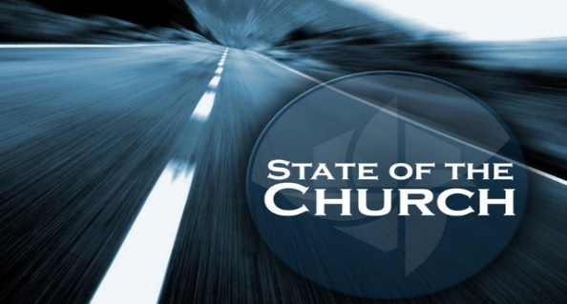
Mark 12:28-31; Matthew 28:18-20
A. Love God! Mark 12:28-30
- Worship!
- God the Creator Desires you to worship Him
- How are we doing in the area of Loving God and worshipping Him?
• Give God Extravagant Worship
- What should You do?
- Spend time in the Word
- Spend time in Prayer
- Choose to enter into Worship
B. Love People! Mark 12:31
- Love one another!
- Extend Unconditional Love to everyone
- How are we doing in the area of Unconditional Love?
- Be available to Help those in need
- What should You do?
- Be willing to Challenge yourself
- Reach out to help Others grow
- Get Involved in the Life of the church
- Heal Hurts and Build Dreams
C. Serve the World! Matthew 28:18-20
- Share the Good News!
- Evangelism: One Beggar telling another where to find Bread
- How are we doing in the area of Serving the World?
- Thrilling Missions Giving and stories of Changed lives
- What should You do?
- Talk about Jesus wherever you are and go
- Invest in the Kingdom of God all around the World
- Pray! Give! Go!
Honolulu Assembly of God February 4, 2024

