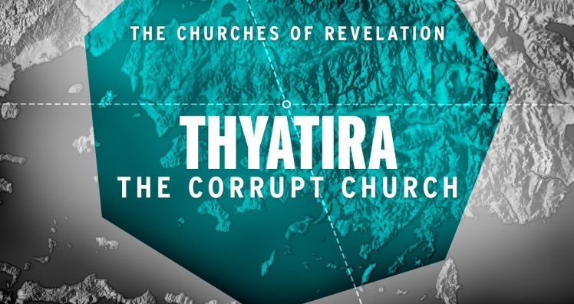
Beware Corruption!
Revelation 2:18-29
1. Commission v18
- The Background of the Ancient City of Thyatira
- Status Today
2. Commendation v19
- Their Spiritual Deeds
- Their Love and Faith, Service and Perseverance
- Their Spiritual Growth
- It must have seemed a very “Attractive” church
3. Condemnation v20-23
- They tolerated the prophetess Jezebel
- Who was She?
- A ruthless, immoral Seducer of the people
- What was her Sin?
- If business practices Conflict with your Christian principles, then your principles have to Go
- Thyatira Today: The Church of the Open-Minded Tolerance
John McArthur: “Smyrna was assaulted by a Synagogue of Satan, Pergamos was literally in the Throne of Satan, but Thyatira had plummeted into the Deep Things of Satan. When you love your Lord Less, you love the world More…and tolerate Sin.”
- When people deliberately reject the Lord’s Authority,
He is no longer their Lord and Master
4. Correction and Challenge v24-29
- Correction: Hold On
- Challenge
- I will give you Authority over the nations
- I will give you the Morning Star
Honolulu AG 7 Letters to your Church October 25, 2020

