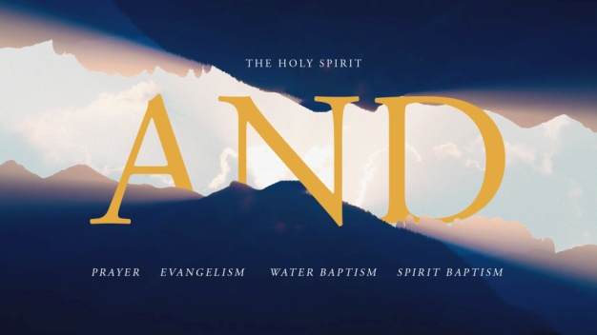
The Holy Spirit and Spirit Baptism
Acts 1:4-8; 2:1-4
A. What is Spirit Baptism? Acts 1:8
- Spirit Baptism is a spiritual encounter Different and Separate from Salvation, empowering you with greater Anointing for ministry
- Spirit Baptism happens Five times in the Book of Acts: 2, 8, 9, 10, 19
- The Holy Spirit is now Inside and Outside, surrounding your life
B. Who can receive Spirit Baptism? Acts 2:38-39
- Spirit baptism is promised to Every follower of Jesus by both Jesus (Acts 1:4-5) and Peter (Acts 2:38-39)
- Salvation is the only Prerequisite; anyone who is saved is fully Qualified
- God is not looking for you to become more Spiritual before you receive; receiving the Holy Spirit Now will help you Become more spiritual
C. How can I be Sure that I have received Spirit Baptism? Matthew 28:19
- You will begin to pray in a New language as the Holy Spirit Prompts you; Acts 2:4
- The main outcome of Spirit baptism is Empowered communication
D. How do I receive Spirit Baptism? Acts 2:1-4
- Draw near to Jesus in Prayer
- Jesus will begin to Pour Out His Spirit upon you
- You begin to speak out Loud from the inner urging of the Spirit rather than your Known language and reason
- Like salvation, Spirit baptism is a Free gift; Acts 2:38. Free gifts are not Earned but simply Received; Luke 11:11-13
- The supernatural part of speaking in tongues is not our Speaking but rather What we are speaking
Honolulu Assembly of God AND June 12, 2022

