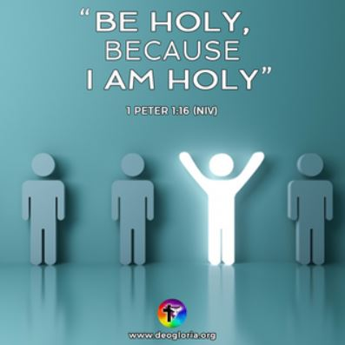
Chosen to be Holy!
1 Peter 1:13-2:1
“Sanctification is making holy what was before Defiled and Sinful”
1. Chosen to be Set Apart
- From Sin
- You weren’t just Ignoring God; you were His Enemy
- You weren’t just Disobedient; you were Dead in your sins
- To God
- Once Tabernacle articles were Separated to God, they were not to be used for Ordinary purposes again
2. Chosen to be Different; 1 Peter 1:13-2:3
- Choose to Think Different; v13-16
- To be Different begins with proper Preparation of your Mind; GIGO
- Choose to Live Different; v17
- Be willing to be out of Step with what the World says
- Choose to Love Different; v22
- Love sets us Apart; it’s the Litmus Test
- May our Love be like Christ’s: Sincere, Deep, and Pure
- Choose to Speak Different; 2:1
- The words you use are a Leading Indicator if you are truly Different; Use your words to Build up
Thought for the Week: “If the church wants to make a difference In the world,
it must be different From the world!” (Ekklesia: The “called out” ones.)
Honolulu Assembly of God Chosen! August 14, 2022

