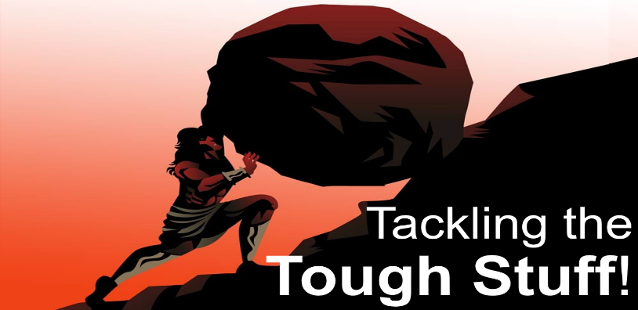
Worry!
It’s a Killer
Matthew 6:25-34
Ulcers are caused, not by what You eat, but by what is Eating you
Worry won’t help tomorrow’s Troubles
but it will ruin today’s Happiness
Worry is the Interest we pay on tomorrow’s Troubles
Lessons from the Sermon on the Mount in Matthew 6:25-34
A. Don’t Worry about Today: God will Provide
- The Lord is Jehovah Jireh, our Provider
- Worry is Wasteful; it says, “I can’t Trust God!”
- He provides for the birds (v26), flowers (v28-29), grass (v30),
and He will provide for You
- Tomorrow is a New day, so don’t take Today into Tomorrow
- The Lord’s mercies are new Every morning
B. Don’t Worry about Tomorrow: God is in Control
- We have great Uncertainty about the Future, which leads to Worry
- What is our greatest fear? What Might happen
- How can you add a Single hour to your life? You can Waste an hour but you can’t Add one
- You can Worry or you can Trust. Which is better?
C. Choose the Right Priority v33
- Seek First the Kingdom of God and His righteousness
- Don’t pursue what Might or might Not happen
- Instead, pursue what is Eternal
- Everything else will be added to you as well
- You don’t have to Strive after what you need; God will Provide
Action steps: If you can do something about your situation, Do it.
If you can’t do anything about it, Release it to the Lord.
Honolulu Assembly of God Tackling the Tough Stuff September 14, 2025

