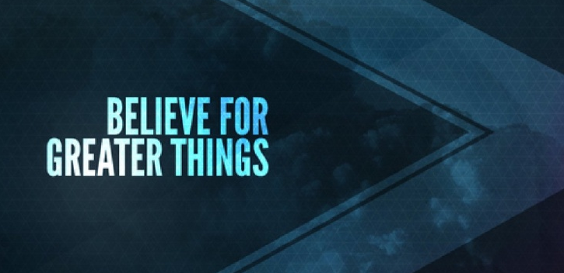
John 14:12
What Greater Things are you believing for in 2021?
A. Sarah – the Laugh of Faith
- The Laugh of Unbelief; Genesis 18:10-15
- God is with us in the Long years when nothing Visible is happening
- God is up to something whether we Believe it or not
- The Laugh of Faith; Genesis 21:1-7
- Like Sarah, you will have the 2nd laugh when the outlandish Promise of God becomes Reality in your life
B. Naomi – Imua for Jesus
- The Heartbreak of Circumstances; Ruth 1:19-21
- Things appeared to go from Bad to Worse
- By Faith, Keep Moving Ahead; Ruth 4:13-17
- Keep Believing God and you will receive the Reward
C. Mary – the Beauty of Surrender
- She Submitted in spite of an Uncertain future; Luke 1:26-38
- She was given a Difficult challenge but readily Surrendered
- Like Mary, none of us really Know what it means when we say Yes to God’s call
- Stan Steward: “Sometimes there’s a big difference between living a Good life and living the life God has Prepared for you”
- Are you willing to go the Full distance with Jesus?
Honolulu Assembly of God January 10, 2021

