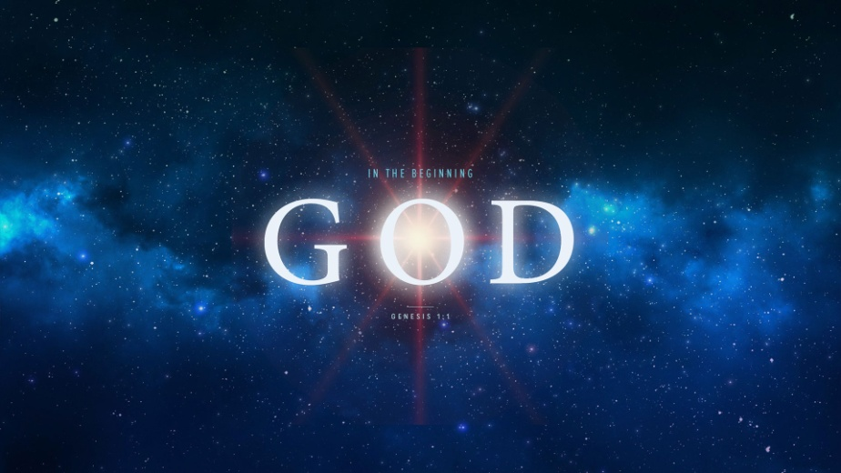
In the Beginning God Created Man
Genesis 1:26-28, 31
1. Where Did I Come From?
(How did God create man?)
- God Formed man from the dust of the ground
- God Spoke the universe into existence with His word but He lovingly Fashioned man by His hand
- You are Not an Accident of Nature
- Man is a little bit of Heaven and Earth
- You are the Pinnacle of God’s Creation
- Man is His Crowning glory
- You have Value and Purpose
- He created us in His Image, breathed into us the Breath of Life and created in us a Soul
2. Why Am I Here?
(Why did God create man?)
- To be in Relationship with God
- The King who created the universe wants to Know you and be in Relationship with you
- To Glorify God
- Our greatest purpose is to Praise and Worship our Creator
- To Work with God
- God commanded man to Rule over the earth
Honolulu Assembly of God In the Beginning God July 26, 2018

