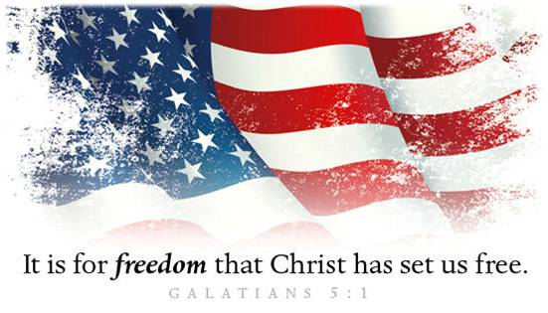
Celebrate Freedom 2020!
A. Our Freedom as Americans
- The Blessing of Freedom
- Freedom to Live anywhere
- Freedom to Travel
- Freedom of Speech
- Freedom to Serve God
- The Responsibility of Freedom
• Pray
• Register to Vote
• Get Informed
• Help elect Godly people
• Vote
• Love!
B. Our Freedom as Christians
- Freedom from Sin and Bondage to Satan; Galatians 5:1
- Jesus Christ has set us Free
- Why? To Live in Freedom
- Warning: Do not become Enslaved again! Galatians 5:13
- Key: Not political Independence but spiritual Dependence upon Jesus Christ
- Paradox: To become truly Free, you must become a Slave to Jesus Christ
- What are you willing to do Now in response to what Jesus has Done for you?
Honolulu Assembly of God July 5, 2020

