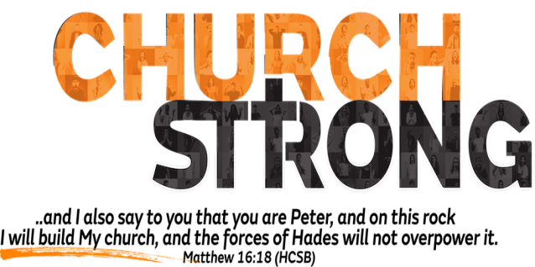
If the Church wants to make a Difference in the world,
it must be Different from the world.
A. The Church must be Strong to endure the Last Days; 2 Timothy 3:1
- The Last Days will be Difficult and Perilous times
- There is much Confusion today
- Wrong is Right and right is Wrong
- Due to the increase of wickedness, the love of Most will grow Cold
- Thankfully the pains of the Last Days here are not the End
B. The Church must be Strong in the Spirit; Ephesians 6:10
- The only accurate measure for the Church is the Bible
- What makes the Church Strong is not Natural but Supernatural
- “Church Strong” believers are:
- Passionately in Love with God
- Dedicated Unselfishly to Christ and His cause
- Filled and Walking in the Spirit
- If you are not Empowered by the Spirit, you will get Beat Up! Acts 19:13-16
C. The Church must be Strong to defeat the Devil’s Strategies;
2 Corinthians 10:3-5
- Satan is Sly and Deceitful; John 10:10
- If you are Unaware of and/or Unprepared for his strategies, you will be in Big trouble
- Thankfully we have Weapons to defend ourselves against him
- Put on the Full armor of God; Ephesians 6
- After you have done everything, you will still Stand Strong
- No Fear! No Retreat! No Surrender! No Defeat! Be Strong!
Honolulu Assembly of God February 26, 2023

