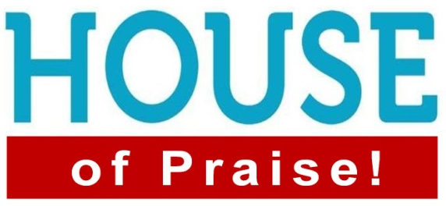
Psalm 96:1-9
1. God our Father Deserves to be Worshipped
- Thank Him for What He has Done
- An attitude of gratitude is the Antidote for selfishness
- Praise Him for Who He Is
- Real love for God is more than loving Him for what He can Do
- When you begin to understand Who He is, you cannot help but respond in Praise
- The King deserves all Honor and Adoration
- OE “Worthship”: To declare Worth to something or someone
- When we declare His Glory, we are making Him greater in our Understanding
2. God our Father Desires to be Worshipped
- He Invites us to come into His presence and worship Him
- He does not Need you to do so but He Desires you to worship Him
- He gives you a Personal invitation to come into His presence
- Come Bless the Lord; Hallel (Praise) + Yah (Jehovah) = Hallelujah
- God Desires the Praises of His people
- From the Beginning, God is looking for those who will worship Him
3. We were Created to Worship Him
- Result: We will worship Something or Someone
- It is not a matter of If, but of What or Who
- God uses that Desire to draw us to Himself
- Augustine: You were created with a “God-shaped Hole” and you will not be content until you find your Rest in Him
- When we gather, come Ready to worship
- It is essential that you Prepare your heart to enter His Presence
Honolulu Assembly of God Welcome to the House February 5, 2023

