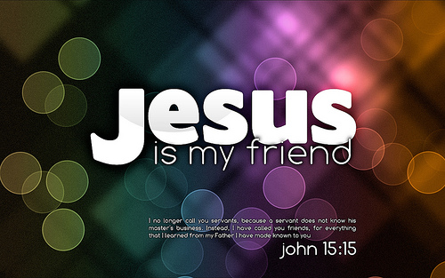
Jesus, your Forever Friend
John 15:12-15
A. Jesus no longer calls you a Servant v15
- We deserve to be in the Lowest place
- We deserve the Worst and the Least
- But God sent His Son to Bridge the separation
B. He calls you Friend v14
- He reached down to your Lowly place to Lift you up
- Contrast the Religions of the world; Do versus Done
- Jesus was criticized for spending time with Sinners
- He laid down His Life for you His Friend
C. If you do what He Commands you v14
- You cannot Earn His affection
- You do not have to Perform to get His approval
- Jesus is your Best Friend; He Deserves your Best
Jesus “friended” you when He took your place of punishment
on the Cross. Will you give your life to Him in return?
Friend Day April 11, 2021 Honolulu Assembly of God

