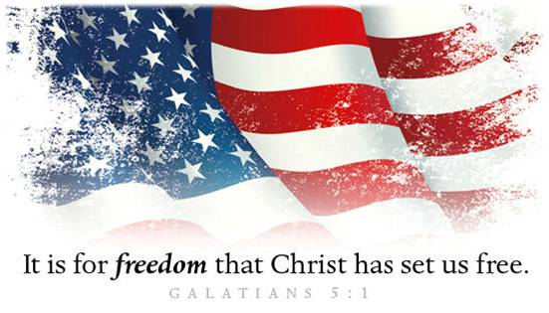
Celebrate Freedom!
A. Our Freedoms as Americans
- Freedom to Live anywhere
- Freedom to Choose
- Freedom to Vote
- Freedom of Speech
- Freedom of Religion
B. What is? our Responsibility?
- Speak up
- Vote
- Pray
C. Our Freedom in Christ; Galatians 5:1
- Freedom from Sin and Bondage to Satan
- Jesus Christ has set us Free
- Why? To Live in Freedom
- Freedom to live in Kingdom of Righteousness
- Freedom to live as a Child of God
- Freedom to live a Victorious Christian Life
- Warning (v1, 13): Do not become Enslaved again!
- Instead of living in Sin, we are now living for Self
- Key: Not political Independence but spiritual Dependence
- Paradox: Freedom and Slavery
- To be truly Independent, we must become absolutely Dependent upon Jesus Christ
- When we choose to do what We want, it leads to Slavery
Honolulu Assembly of God July 5, 2021
The Christian’s Declaration of Independence
I am free from Failure, for “I can do all things
through Christ who strengthens me” Philippians 4:13.
I am free from Want, for “My God shall supply all my needs
according to His riches in glory by Christ Jesus” Philippians 4:19.
I am free from Fear, for “God has not given us a spirit of fear,
but of power, and of love, and of a sound mind” 2 Timothy 1:7.
I am free from Doubt, for “God has given to every man
the measure of faith” Romans 12:3.
I am free from Weakness,
for “The Lord is the strength of my life” Psalm 27:1.
I am free from the Power of Satan, for “Greater is
He that is in me than he that is in the world” 1 John 4:4.
I am free from Defeat, for “God always leads us
in triumphal procession in Christ” 2 Corinthians 2:14.
I am free from Ignorance, for “Christ Jesus
has become for us wisdom from God” 1 Corinthians 1:30.
I am free from the Curse of Sin, for “the blood of Jesus,
His Son, purifies us from all sin” 1 John 1:7.
I am free from Worry, for I can
“Cast all (my) cares upon Him, for He cares for (me)” 1 Peter 5:7.
I am free from Bondage, for “Where the Spirit of the Lord is,
there is freedom” 2 Corinthians 3:17.
I am free from Condemnation, for “There is therefore now
no condemnation to them which are in Christ Jesus,
who walk not after the flesh, but after the Spirit” Romans 8:1.

