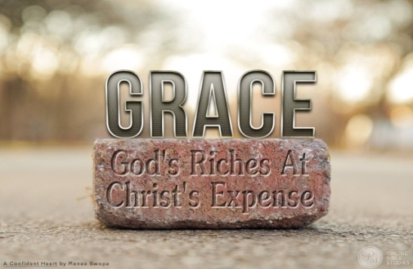
Ephesians 2:1-10
A. Receive Grace
- Before and After
- Before
- We were Dead in our transgression and sins v1
- We were Gratifying the cravings of our sinful nature v3
- We were Objects of wrath v3
- But God! v4
- After
- God made us Alive with Christ v5
- He raised us Up with Christ v6
- He Seated us in Heavenly Places with Christ v6
- Everything we receive is because of God’s Grace
- Grace is God giving us what we don’t Deserve
- We cannot Earn it and could never be Worthy of it
B. Live Grace
- We are Saved by Grace and we Live by Grace
- It is tempting to be Saved by Grace and then try to Live by Works
- Problem? All based on our own Efforts to please God
C. Give Grace
- What I Receive, I must Give
- Tragedy? Many Christians are Saved by Grace but Judge others by the Law
- Lavish others with the Grace God has Given you
Honolulu Assembly of God Freely Give! September 26, 2021
Honolulu Assembly of God
World Missions Update

Recipient | August 2021 | 2021 Total
BGMC  At Home & Around the World | 164.79 | 1,244.64
Aloha Pregnancy Care and Counseling Center | 50.00 | 400.00
Hawaii Teen Challenge  Helping those with addictions to break free | 50.00 | 400.00
Hawaii Assemblies of God  Impacting all Hawaii | 50.00 | 400.00
The Shelter  Homeless ministry on Oahu | 50.00 | 400.00
Bell, Terry & Julie  Panama | 30.00 | 240.00
Brown, Mark & Sarah  Philippines | 50.00 | 400.00
Carter, Chris & Lindsey  Japan | 50.00 | 1700.00
Decker, Elizabeth  India | 30.00 | 240.00
Kitano, Joyce  Japan | 35.00 | 280.00
McKinney, Everett & Evelyn  Singapore | 125.00 | 1000.00
Rojak, Phillip & Kimberly  Papua New Guinea | 60.00 | 480.00
Scott, Doug & Suzan  Global University | 50.00 | 400.00
Convoy of Hope  At Home & Around the World | 100.00 | 100.00
Disaster Relief, Local Outreach, Give Hope, Media Online,  Projects, other Missionaries,  AG Fellowship Partners |  | 1,668.87
Total Given | $ 894.79 | $ 9,353.51

