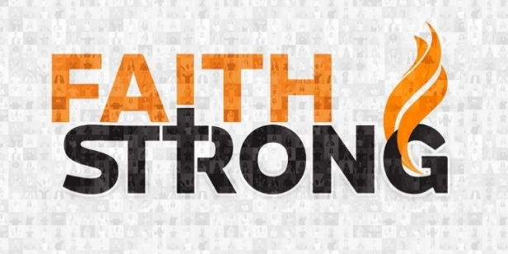
Believe! Mark 5:25-34

A. See It
- She Saw the Possibility of a Miracle
- Her life had been filled with Hopelessness
- See it in the Supernatural; Grab Hold of your Miracle
- If you are Not believing God for anything, there is a 100% chance you will get Nothing

B. Speak It
- She Said to herself; it is the Language of faith
- There is Power in your Words
- Don’t speak words of Discouragement and Defeat
- Speak words of Faith; declare His Word

C. Do It
- It’s not enough to See and Speak it; you must put your Faith into Action
- Seeing and Speaking are Not Enough; we must Step Out

D. Trust in Jesus
- Without Jesus, Seeing and Speaking and Doing are Insufficient
- The woman’s faith was not in Faith; Her faith was in Jesus

E. Quick Takeaways
- Faith requires Risk
- True Faith gets God’s Attention
- Jesus accepts Imperfect Faith
- When Jesus heals, it is Complete
- Jesus is moved to Action by our faith
Digging Deeper: Are you in a desperate, impossible situation? Are you putting your trust in your own ability? in your faith? Or in Jesus?
This Week: Believe! See it, Speak it, Do it. When you are in a Hopeless situation, put your trust in Jesus for a Miracle!
Honolulu Assembly of God Faith Strong! October 15, 2023

