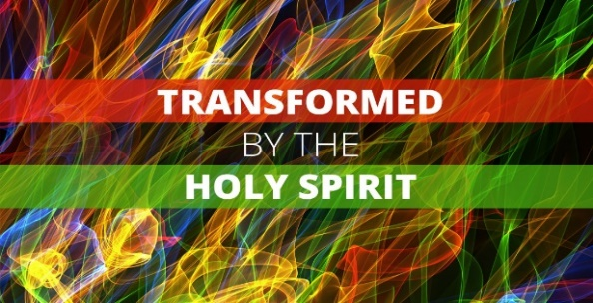
2 Corinthians 3:7-18
The power of the Holy Spirit was unleashed in the world 2,000 years ago when the Church was birthed on the Day of Pentecost (Acts 2). That power is still available for us today and, through us, to the world. The Holy Spirit gives us Light, Freedom, and New Life.
1. Illumination – Light v7-16
- Illumination of Moses’ radiant face; Exodus 34:19-35
- Our radiance is a Reflection of Christ’s radiance
- Illumination of your Mind; 1 Corinthians 2:6-10
- The work of the Holy Spirit is to Reveal Jesus to us
- Illumination of your Life; Acts 2
- When Jesus lives in your life, it should make a Difference
2. Liberation – Freedom v17
- Tyranny of the Old Covenant; v9-11
- Be set free from the Restrictions and Traditions of men
- Freedom to Worship
- Invite the Holy Spirit to Break you out of your Ruts
- Freedom to Live; Galatians 5:13-18
- Give up your Striving and Rest in Jesus
3. Transformation – New Life v18
- Not Imitation
- Bible: Our efforts are totally Inadequate
- Holy Spirit Revolution
- When you give the Holy Spirit Control, He will make the Changes
Next Steps: Am I striving in my own efforts?
Have I been baptized in the Holy Spirit,
with the evidence of speaking in unknown tongues?
Am I relying solely upon the Holy Spirit?
Am I riding on the wind of the Spirit?
Honolulu Assembly of God May 21, 2023

