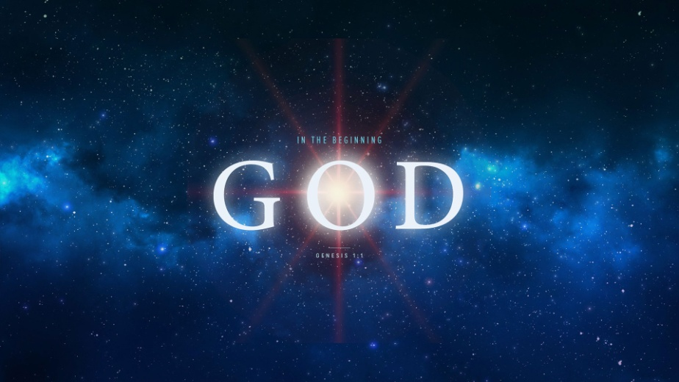
Sin Enters the World!
Genesis 3:1-19
1. The Problem of Sin
- What is Sin?
- Sin literally means to “Miss the Mark” (ἁμαρτία)
- Sin brings Separation from God
- We are Separated from God by Who we are, not by What we do
- Why did God allow Sin to Enter the world?
- The Test of man’s Obedience
- God wanted Worshippers not Robots
- What were the Consequences of Sin?
- Separation: Physical, emotional, spiritual
- The Ultimate Separation? Hell
- Death: Physical, emotional, spiritual
2. The Antidote to Sin
- Be Cleansed by the precious Blood of Jesus
- Jesus has paid All the price for sin in Full
- Flee from the very Presence of Sin
- God Fulfills your Desires but Satan is all about Shortcuts
- Eve got what she Asked for, but not what she Wanted; James 1:13-15
- Learn to Hate Sin
- We don’t Do what we don’t Like
Honolulu Assembly of God In the Beginning God! August 23, 2018

