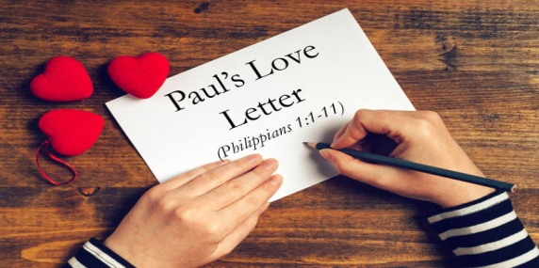
Paul the prisoner urged his readers to Rejoice in the Lord! Why?
1. Paul himself had Joy, part of the Fruit of the Spirit; Galatians 5.
2. He was Laser Focused: “To live is Christ and to die is gain”; 1:21.
A. Thanksgiving: I have you in my Mind v3-6
- Paul’s Remembrance
- God changed potential Sorrow of memories into Joy
- The Philippian believer’s Partnership
- Their partnership was manifested in their Generosity
- Our shared Confidence
- The work God does For us is Salvation, In us is Sanctification, and Through us is Service
B. Affection: I have you in my Heart v7-8
- The Philippian believer’s Participation
- Philippians partook of God’s grace through sacrificial Giving, devoted Intercession, and faithful Christian Living
- Paul’s Longing
- He was a model of the Affection and Compassion of Christ
C. Intercession: I have you in my Prayers v9-11
- Loving
- What is the Prescription for disunity and fault finding? Love is the Antidote
- Discerning
- Discern between what is Good, Bad, and Best
- Fruitful
- Christ desires to develop His Character in your Life
- He wants people, when they look at you, to see Himself
Honolulu Assembly of God February 19, 2023

