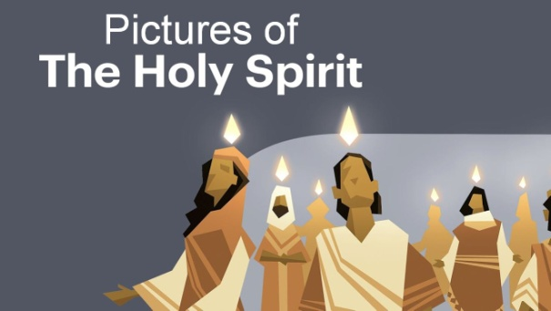
Acts 2:1-4, 16-17
What do you know about the Holy Spirit? We want to spend time now getting to know Him better.
Jack Hayford, well known pastor and author, writes: “The Holy Spirit does not seek to be mysterious, but He is the most mysterious of the Godhead. We can read in the Word about the Father, and we can read about the Son who came and walked among us. But Jesus tells us that, when the Spirit comes, He will not speak of Himself....The workings of the Holy Spirit are invisible, glorious, and gentle. He never tells us about Himself. He comes to glorify Jesus—helping us to see Jesus more, to understand Jesus better, to respond to Jesus more obediently, to love Jesus with a deeper heart of commitment.”
The Bible uses word pictures to help us understand the Holy Spirit. He is pictured as Oil, Wind, Water and Fire. All are very relevant and needed in our day.
1. Fresh Oil
- Isaiah 61:1-2; 1 John 2:20
2. Fresh Wind
- John 3:7-8
3. Fresh Water
- Hosea 6:3; Joel 2:23; John 7:37-39
4. Fresh Fire
- Matthew 3:11; 1 Thessalonians 5:19
Honolulu Assembly of God June 7, 2020 Celebrate Pentecost!

