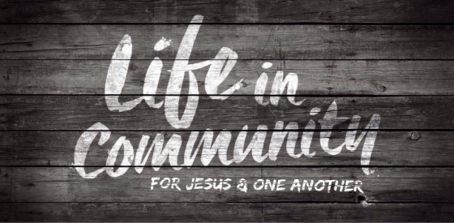
Genesis 3:6-13; Ephesians 2:11-22
A. Receive Community
- Glorious Communion with the Father; Ephesians 1:3-12
- He has blessed us with Every spiritual blessing
- Our ultimate communion will be Union with Jesus; 1 John 3:2
- Beautiful Community with Others; Ephesians 2:11-22
- Reality
- Equality
- Acceptance
- Authenticity
B. Live Community
- Recognize the Value of Community
- Everyone is Needed in the Body of Christ
- Recognize the Necessity of being in Community
- There are no Lone Ranger Christians
- There is Strength in Community
- We are Vulnerable in Isolation but Empowered in Community
C. Give Community
- Choose to Pursue Fellowship
- The Early Church had everything in Common; Acts 2
- If I am not in fellowship with my Fellow Man, am I in fellowship with the Father? 1 John 1:3-7
- Be Intentional about making meaningful Connections
- I must Choose to be in Relationship with you
- Do you truly Love people?
- People do not care how much you Know until they know how much you Care
Honolulu Assembly of God Freely Give! November 7, 2021

