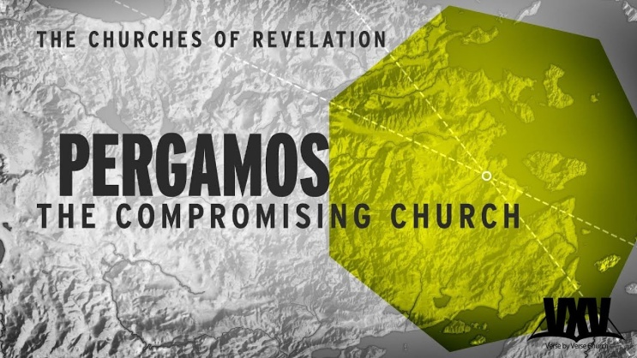
Don’t Compromise!
Revelation 2:12-17
1. Commission v12
- The Background of the Ancient City of Pergamos
- Status Today
2. Commendation v13
- Faithful in spite of a Deadly Environment
- Faithful in spite of a Deadly Persecution
- What are you Facing this week?
The sword of Protection is also the sword of Judgment
It is more important for the Church to fear the Sword of Christ than the sword of Rome
3. Condemnation v14-15
- Compromise with False Teaching
- When you live in a right Relationship with God, He turns even the devil’s worst to Blessing
- Compromise with False Living
- Once Compromise Begins, where does it Stop?
- Deadly Danger of Compromise Today
- There is danger in living for what is Convenient instead of what is Right, for the Now instead of what will Last
- Don’t straddle the Fence! Serve Jesus Christ or serve the Devil, but don’t try to do Both
4. Correction v16
- Repent over that which is False
- Repent over that which is Self
Honolulu AG 7 Letters to your Church October 18, 2020

